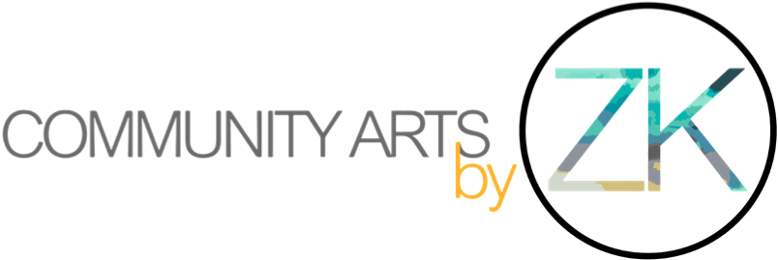
Community Arts by ZK
Office 2
Northlight Estates
Northlight Parade
Brierfield/Nelson
Lancashire
BB9 5EG

Tel: 01282 222334
Email: info@communityartsbyzk.co.uk

Creative Practitioner Year 2: Phase 3
Job Description
About Community Arts by ZK
Community Arts by ZK (CAZK) (https://www.communityartsbyzk.co.uk/) is an award-winning community interest company based in Pendle. At CAZK, we use art as a driving force to bring communities together from different age ranges, socio-economic and cultural backgrounds, with a strong emphasis on community cohesion, integration and wellbeing. We design and deliver art projects, activities, and workshops that value, encourage and engage people in the community, allowing them to express themselves more effectively and communicate their ideas in a creative way. Our workshops and projects cover a broad range of techniques, and we work with creative practitioners and artists from across the world and from a variety of creative disciplines. Examples include fine art, mixed media, photography, traditional and contemporary methods, textiles, environmental artists, installation, and sculpture.
​
- 11 week contract, 1 workshop a week.
- £194 per session ( ½ day planning & ½ day delivery / To be requested in 2 instalments, 40 % and 60%)
- 11 sessions in total.
- Fixed workshop day of 'Thursdays' starting from 12th March 2026 at Northlight Estates, Brierfield.
​
​​​
HAFA (Healing Arts For All)
​
HAFA is a three-year creative heritage project (2025–2027), funded by the National Lottery and Paul Hamlyn Foundation. It explores the South Asian community’s role in Pendle’s industrial history. In the 1950s, South Asian families were invited by the Queen and government to work in the textile industry, including at Brierfield Mill, a Grade II listed former cotton mill. Their stories and contributions are largely absent from mainstream archives.
​
HAFA places participants’ voices at the centre of the project, enabling them to explore, research, and creatively express their heritage narratives through 12 progressive creative phases. The project focuses on empowering participants to reclaim their history and contribute to a multi-layered archive of community heritage.
​​​​​
​

What we are looking for:

A Creative Practitioner specialising in digital art for example 3D imaging, Virtual Reality, Augmented Reality etc..
CAZK is looking for a forward thinking, radical Creative Practitioner to work alongside our local community during a twelve-week phase of our three-year long creative heritage project ‘Healing Arts for All’ (HAFA).​
​​​
Digital Artist Role:
​
- Each week of the phase there will be either a workshop or research trip (including to museums, art galleries, archives, and local mills) whereby the Creative Practitioner will be supporting participants to collect research and ideas they may want to creatively translate in the workshops. The Creative Practitioner shall then support participants to develop and explore their own research interests in new and innovative ways through teaching them the specific, designated creative medium of the phase.
- At this stage of HAFA participants will have developed a research proposal which will guide the direction of the project.
- Participants will have also created a portfolio of creative outputs, and collected a large amount of information/documentation relating to the Pendle’s industrial heritage and lives of those who live/have lived here which they will be drawing on for inspiration going forward in the HAFA project.
- The Creative Practitioner’s role will be to support participants in developing and exploring their proposal through the selected creative medium.
- The Creative Practitioner will work with the local community and guided by their research proposals to create a final digital art piece for example an AR app, creating engagement with the general public. The scope is limitless. We are interested to hear your ideas and proposals in the application!
​
​

Experience:
- A Creative Practitioner specialising in Digital Art.
- A Creative Practitioner with experience in developing and implementing creative research methods.
- A Creative Practitioner with experience in creating socially engaged creative outputs.
- Relevant Artistic Degree.
- DBS checked.
- A Creative Practitioner with experience with engaging and working with people from diverse cultural backgrounds and listen to the voices of our community, supporting it to pursue its research interests.
​

Desirable:​
- An interest and enthusiasm for working as a Creative Practitioner in the context of post-industrial, diverse town such as Brierfield.
- An interest in heritage.

​

Outputs:
- You will develop and support the community to create final creative outputs that will be exhibited in the final exhibition at the end of the third year of the project (2027).
- Each participant shall develop a portfolio of work showing the development of their research proposal and the creative skills they are developed in this phase of the project.
​​

How to apply:
- Submit a two-page (maximum) Expression of Interest outlining why you are interested in HAFA and how your Digital Art practice could support this phase of the project.
- CV.
- Portfolio of previous work (with relevant links).
- Social media handles (optional).
- Send to: info@communityartsbyzk.co.uk
Deadline for applications: Thursday 22nd January 2026
​
Start Date: 12th March 2026 for the first workshop session, and then every consecutive Thursday for 11 weeks, apart from one week during the Easter Holidays where there will be a break in activity.

